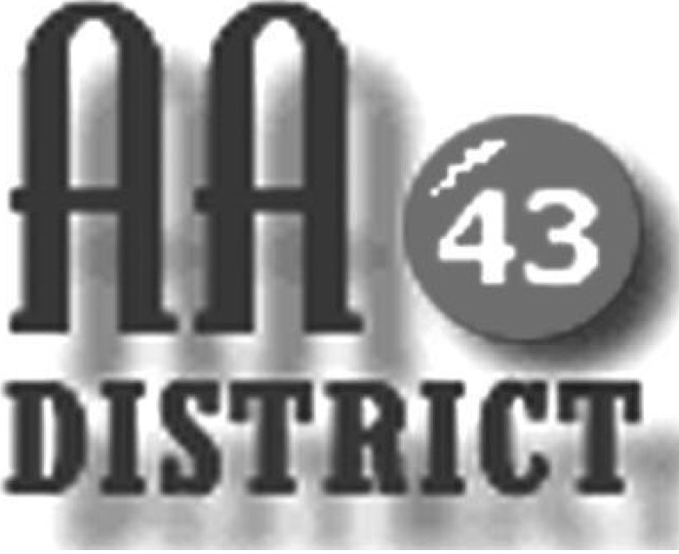

Meeting Minutes
March 21, 2017

Groups Represented:

Keep it Simple Sunday
Millheim Saturday Morning Meeting
Monday As Bill Sees It
Monday 5:30 Happy Hour Promises
Sunday Night 11th Step Meditation
Sunday Night Healing Group
Thursday Sober Sisters
Tuesday Night Step Meeting Bellefonte
Wednesday Night Bellefonte Candlelight
Wednesday Night Mill Hall
Wednesday One-Hour Step
Friday Night Spiritual Side
Wednesday Night Living in the Solution

The meeting called to order at 7:15 pm with the Serenity Prayer.

Officer Reports:

Officer-at-Large (Jen): Absent. It was noted that the next meeting is scheduled for April 11 at St. John’s Lutheran, Bellefonte.

Secretary (Paul H.): Several corrections were identified for the February 14 meeting minutes. Roger G. reported that the Boalsburg Monday As Bill Sees It group was represented at the meeting but is not listed in the minutes. It was also confirmed that Todd W. will continue as chair of the visitation committee. With these corrections, the minutes of the February 14 meeting were approved.

Paul distributed a draft 2017-2018 panel roster listing each panel member by first name with e-mail and phone numbers for corrections and additions. He also distributed a meeting list for corrections.

Treasurer (Shannon): The District financial report for February 2017 is attached. Shannon reported that as of February 28 the District fund balance is $107 above the prudent reserve of $1,200. There was a discussion of the need to update the District meeting list and a copy of the current list was circulated for any corrections or corrections. It was agreed that Bob and John would take this information and update the web site to reflect these changes.

Web Servant (John): John reported that $34.90 had been spent for an ad-free graphics package needed for the District website. This was submitted to Shannon.

ADCM (Bob): Bob reminded the panel that Medallion Night is May 5 and the Wednesday Night Keep It Simple group is hosting. There was some discussion about earlier confusion that occurred because some thought that the Sober Sisters group were to host this time. Carrie indicated that she would reach out to the Friday Teachable Speakers group, which coordinates Medallion Night, to see if any help is needed.

DCM (Carrie): Carrie reported that District Day had been a big success and there was strong agreement on this. Carrie distributed and reported on the Area 59 committee report on the 2016 EPGSA conference. The conference lost approximately $6,000 and most of this was due to food costs. As a result, the registration fees and packages are being revamped to provide more choices but also to increase revenue to cover the costs. It was noted that sending the GSR to the EPGSA conference is the single largest annual expense for most groups. It was suggested that attendees from our district could car pool as one way of cutting costs. Carrie distributed material pertaining to other Area 59 events including the April 2 Pre-Conference Sharing Day and the June 10 Mini Assembly which engage districts and groups in planning for the next EPGSA Conference.

Summaries and Actions

Bob announced that he is obtaining a new GSO-published brochure on Safety in AA. This will be made available to the groups. It was also noted that the Howard Monday Night meeting is having a one-year anniversary.

Committee Reports

Archives: Paul H. had no report at this time. It was noted that the previous chair (Vicki) has the key to the Archives cabinet, a scanner purchased with District funds, and thumb drive also purchased with District funds containing scanned archive material. Paul and Linda M. agreed to coordinate with Vicki about these items.

Corrections & Institutions (C&I): Bill Q. explained that currently there are meetings being held at area facilities and institutions including Centre County, Benner, Rockview, the Youth Detention Center, and the Meadows. He explained that there is a need for issues of the Grapevine and other literature. He suggested waiting until sufficient funds are available from pink can contributions and other sources for a purchase of literature in the range of $500-600. Bob also said that there is always a need for people from the groups who are willing to obtain the necessary clearances and participate in these meetings. He suggested that the Meadows could be a good place to start for those interested in this type of service.

Cooperation with the Professional Community (CPC):

Public Information (PI):

Structure:

Visitation:

Old Business

New Business:

A suggestion was made during the meeting that I district inventory be performed. Carrie agreed to bring forward a suggestion at the next meeting on how this might be undertaken.

The meeting adjourned at .

