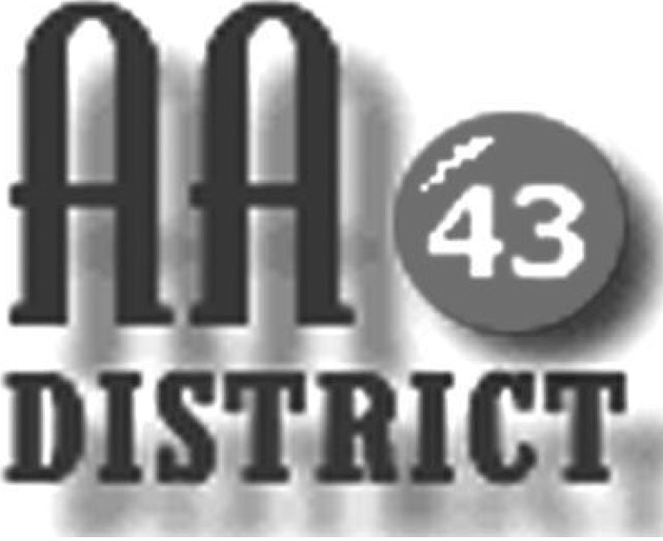

Meeting Minutes

May 9, 2017

Groups Represented:

Sunday Came to Believe
Boalsburg Monday As Bill Sees It
Keep it Simple Sunday
Centre Hall - Millheim Group
Mill Hall Group
Monday 5:30 Happy Hour Promises
Saturday Morning Gratitude
Thursday Sober Sisters
Tuesday Night Step Meeting Bellefonte

The meeting called to order at 7:15 pm with the Serenity Prayer.

Officer Reports:

Officer-at-Large (Jen): Jen announced that next month’s District 43 meeting will be held June 13 at the Lighthouse Reformed Church in Howard

Secretary (Paul H.): The April 11 meeting minutes were approved with one correction. Paul distributed a newly updated 2017 panel roster for corrections and additions.

Treasurer (Shannon): The District financial report for April 2017 is attached. Shannon reported that as of April 30 the District fund balance is $902 above the prudent reserve of $1,200. Of this total, $176.00 are designated “pink can” funds and 726 is available for other district business. Bob asked whether the report could indicate the groups that are providing the pink can contributions. Shannon said that this could be done. There was a discussion about reimbursing District officers for mileage. It was explained that only the DCM is eligible for mileage reimbursement for travel relating to District business unless otherwise authorized by the panel, and that the mileage rate is the approved rate used by the U.S. government. It was agreed that Carrie and Shannon would monitor mileage expenses to ensure that mileage expenses remain in line with past practice.

Web Servant (John): John asked that anyone wishing to have information about AA events posted on the website should e-mail that information to him. It was noted that the Thursday Night Big Book meeting is not closing as had been previously reported.

ADCM (Bob): Bob reported that he received word from St. Andrews about some changes to meeting rooms at the church on April 28 and 29 due to church activities that weekend. This information was passed on to District panel members as soon as it was received.

DCM (Carrie): Carrie reported on Area 59 events including the April 2 Pre-Conference Sharing Day which she attended, and the upcoming June 10 Mini Assembly. She explained that these events are designed to engage districts and groups in planning for the fall EPGSA Conference. Carrie explained that while District funds may be used to support travel by the DCM, GSRs who wish to attend these events are often supported by their home groups, and that carpooling is always encouraged to save funds.

Summaries and Actions

It was reported that phots of people at AA meetings may be appearing on Facebook or other Internet sites. It was noted that GSO has produced a brochure on “Anonymity in the Digital Age” and that one option being considered is to add the level of “digital media” along with press, radio, and film at which anonymity must be protected. It was suggested that anonymity and digital media should be discussed at the June 10 Mini Assembly. It was also reported that the Sunday 3:00 meeting at St. Andrews has ended.

Committee Reports

Archives: Paul indicated that he may not have time to chair the Archives Committee since he is also serving as District Secretary. Sue T. said that she has contact information for Vicki and that she would pursue the questions about the location of the scanner and thumb drive.

Corrections & Institutions (C&I): Megan announced that all of the men’s meetings need support. It was suggested that it might be beneficial if the website could clearly list the clearance requirements for each facility along with links to the necessary forms that must be completed to gain access to each facility. It was also suggested that the Youth Detention Center can be a good place to begin for those interested in these meetings.

Cooperation with the Professional Community (CPC): It was reported that the letter to professionals in the community which has been in preparation for some months is now ready to be sent and will be sent along with an up-to-date meeting list.

Public Information (PI): It was reported that there is a need for materials and a list will be developed and presented at the next meeting. It was also mentioned that Earl may be less active with this committee than planned because of other obligations.

Structure: It was reported that Bill Q. is no longer the GSR for the Wednesday Night Candlelight group. This change is reflected on the updated panel roster.

Visitation: No major issues were reported.

Old Business

The issue of advertising of AA and the hot line phone number in printed yellow-page telephone directories was discussed. Carrie reported that AA is well represented in the phone books for the Verizon service area. These phone books prominently list AA at no charge. DAX Communications serves several large communities within District 43 including Renovo, Phillipsburg, and Lock-Haven. District 43 has been paying $30 per month to advertise in the DAX yellow-page directories. It is unclear whether this is needed. Carrie will obtain copies of the DAX directories and see whether we can have the same arrangement with DAX that we have with Verizon.

DT gave an update on efforts to resolve the difficulties that residents at the Meadows are having getting to the location of the meeting at the Meadows due to staffing and logistics issues. He has not yet had a discussion on this with the Meadows administration.

New Business: No new business was discussed.

Carrie mentioned that there is an open position on the Centre County Drug and Alcohol Council and that anyone interested should contact a member of the CPC Committee.

It was noted that the meeting list on the website is correct but the printable version does not match what the website says and is incorrect. Jen and Bob indicated that they would update the printable list to match the website.

The meeting adjourned at 8:15 p.m.

