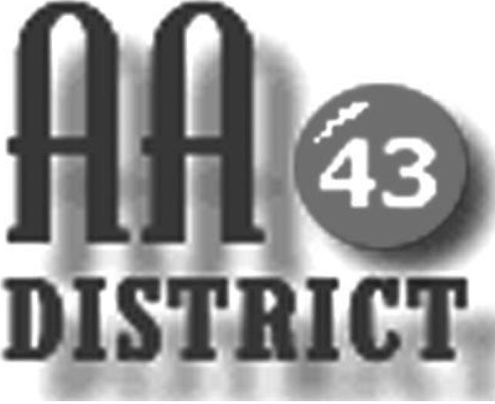

Meeting Minutes

June 13, 2017

Groups Represented:

Sunday Came to Believe
Friday Teachables
Sunday Healing Group
Living in the Solution
Saturday Morning Gratitude
Wednesday Night Bellefonte Recovery
Sunday Eleventh Step Meditation
Mill Hall Group
Sunday Came to Believe
Centre Hall - Millheim Group

Boalsburg Monday As Bill Sees It
Keep it Simple Sunday
Thursday Sober Sisters
Tuesday Night Step Meeting Bellefonte

Primary Purpose – Howard Monday Night

Friday Night Spiritual Side

The meeting called to order at 7:15 pm with the Serenity Prayer.

Officer Reports:

Officer-at-Large (Jen): Next month’s District 43 meeting on July 11 will tentatively be held in Phillipsburg, and the August 8 meeting will be held in Millheim. Jen also announced that the donations received at each monthly District 43 meeting will be provided to the host location as rent for the meeting space.

Secretary (Paul H.): The May 9 meeting minutes were approved as submitted. Paul also distributed a newly updated 2017 panel roster for corrections and additions.

Treasurer (Shannon): Shannon reported that as of May 31 the District fund balance is $631 above the prudent reserve of $1,200. Of this total, $176.00 are designated “pink can” funds and $455 is available for other district business.

Web Servant (John): John reported that the District 43 meeting list has been newly updated and will now be sent to the panel for review. Changes should be sent directly to John. Once any needed changes are made the final updated list will be published on the website.

ADCM (Bob): Bob indicated that he had nothing to Report at this time.

DCM (Carrie): A written DCM report for May 2017 was distributed by Carrie, which is attached. Carrie also distributed materials related to the annual EPGSA conference, schedule for November 305 in Gettysburg. She asked whether District 43 would provide $50 to help support the hospitality room at the EPGSA conference as we have done in the past. It was agreed that Shannon should provide a check for $50 for this purpose. Carrie also reported that there is a continuing need for support of GSO.

Summaries and Actions

Several items were reported. The question of whether “vaping” should be permitted in AA meetings was raised. It was generally agreed that this activity produces odors and vapors that may be offensive to some people so it may be appropriate for home groups to not permit this activity during meetings.

Another issue concerned some confusion at St. Andrews about the times and locations of the various meetings held at the church. It was agreed that as soon as the new updated meeting list is available, Bob will provide to the church a list of the meetings held at St. Andrews.

The issue of newcomers being given misinformation and perhaps being mistreated by members of AA who may have intentions that are no good was also raised. It was agreed that members should be on the lookout for this type of behavior and should try hard to always welcome and provide good guidance to newcomers.

Committee Reports

Archives: Paul reported that with the help of Sue, Vickie had been contacted and it was confirmed that the key to the archives cabinet, the scanner, and the thumb drive are all in the Clubhouse with the archives cabinet.

Corrections & Institutions (C&I): it was reported that the website now clearly lists the clearance requirements for each correctional facility or institutional along with links to the necessary forms that must be completed to gain access to each facility.

Cooperation with the Professional Community (CPC): Roger distributed a sign-up sheet for volunteers to willing to take calls received through the hotline. GSRs were asked to take the sign-up sheet to their home groups and return completed sheets by the next District meeting.

Public Information (PI): Discussion of items for this committee were tabled until the next meeting.

Structure: This committee had nothing to report.

Visitation: Todd explained that this committee plans to take the newly updated meeting list and divide the meetings among committee members and then begin visiting home group meetings. Jim and Shannon expressed interest in participating in visits to home group meetings.

Old Business

Carrie reported that AA is listed at no charge in yellow pages phone directories serving the entire geography of District 43 with the exception of Lock Haven. Carrie agreed to look into what is needed to ensure coverage in Lock Haven. There was agreement that pending resolution of the Lock Haven issue, District 43 should not pay for advertising in any yellow pages phone directories.

A second item if old business concerned service animals in AA meetings. Carrie reported that to comply with ADA requirements, service animals should be permitted in AA meetings. It was agreed that each group conscience should decide how to handle this.

New Business: No new business was discussed.

The meeting adjourned at 8:30 p.m.

