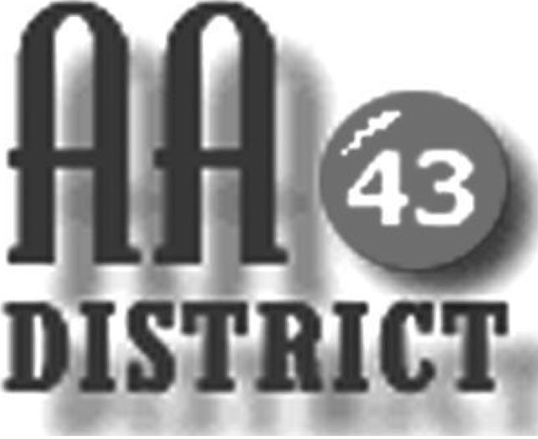

Meeting Minutes

July 11, 2017

Groups Represented:

Living in the Solution
Keep it Simple Sunday
Sunday Eleventh Step Meditation
Centre Hall - Millheim Group
Monday 5:30 Happy Hour Promises
Sunday 6:30 Healing Group

Boalsburg Monday As Bill Sees It

Sunday Came to Believe
Friday Teachables
Wednesday Night Bellefonte Recovery
Friday Night Milesburg Meeting

The meeting called to order at 7:15 pm with the Serenity Prayer.

Officer Reports:

Officer-at-Large (Jen): Next month’s District 43 meeting will be held at Mill Hall Presbyterian church (109 Main St., Mill Hall) at 7:15 on August 8.

Secretary (Paul H.): The June 13 meeting minutes were approved as submitted. Paul also distributed a newly updated 2017 panel roster for corrections and additions.

Treasurer (Shannon): Shannon reported that as of June 30 the District fund balance is $495.36 above the prudent reserve of $1,200. Of this total, $175.65 are designated “pink can” funds and $495.36 is available for other district business.

Web Servant (John): John reported that the newly updated District 43 meeting list has been posted.

ADCM (Bob): Bob reported that Medallion Night will be July 28 at 8:00, rather than the usual 7:00. He asked that people spread the word regarding the time change.

DCM (Carrie): Carrie provided an update and distributed materials on the annual EPGSA conference, schedule for November 3-5 in Gettysburg.

Summaries and Actions

DT reported that he is investigating the potential for establishing a closed meeting at the VA facility in State College.

Committee Reports

Archives: No report.

C&I (Corrections & Institutions): It was reported that there is a need for support of meetings at all of the institutions and especially Clinton County. The website now clearly lists the clearance requirements for each correctional facility or institutional along with links to the necessary forms that must be completed to gain access to each facility.

CPC (Cooperation with the Professional Community): The final updated list volunteers willing to take calls received through the AA hotline will be submitted this week. GSRs were asked to provide any additional names for the list immediately.

PI (Public Information): No report.

Structure: No report.

Visitation: This committee is dividing the meetings among committee members and systematically visiting home group meetings.

Old Business

There was no update on the issue of advertising in yellow page phone directories. AA is currently listed at no charge in yellow pages phone directories serving the entire geography of District 43 with the exception of Lock Haven. Our current understanding is that with the possible exception of Lock Haven, District 43 should not pay for advertising in any yellow page phone directories.

New Business:

Bob explained that District has maintained such a list has been maintained in the past but it has not been maintained and is out of date. Bob announced that he was would be willing to work through the GSRs to generate a district phone list. After some discussion a motion was made, seconded, and approved requesting that Bob work with GSRs to generate such a list to include first name and last initial, phone number, and gender of the group conscience members for each home group.

The meeting adjourned at 8:15 p.m.

