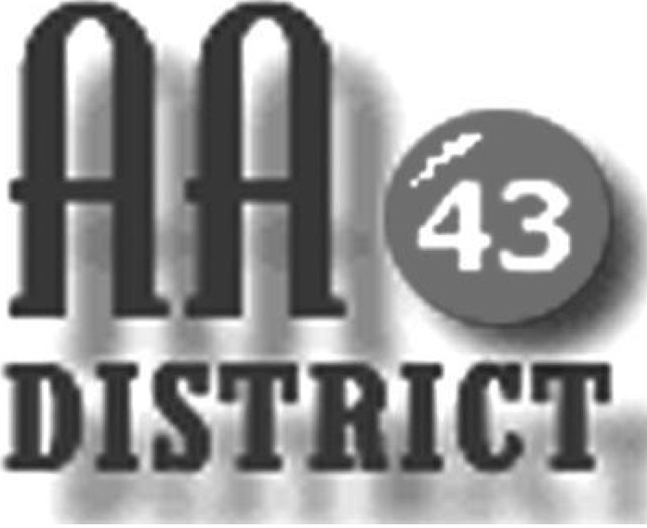

Meeting Minutes

August 8, 2017

The meeting was held in Mill Hall and was called to order at 7:15 pm with the Serenity Prayer.

Officer Reports:

Officer-at-Large (Jen): The Officer at Large was absent. It was noted that the September meeting will be at the Blanchard Church of Christ, 169 Beach Street, Blanchard PA.

Secretary (Paul H.): The Secretary was absent. Bob W. took notes. The July 11 meeting minutes were approved as submitted. It was suggested that meeting minutes should indicate the location of the meeting.

Treasurer (Shannon): Shannon reported that as of June 30 the District fund balance is $269.61 above the prudent reserve of $1,200. Of this total, $203.07 are “pink can” funds designated for corrections literature, and $66.54 is available for other district business. There was some discussion of possible spending for a Grapevine subscription for corrections which was tabled for the next meeting.

Web Servant (John): No report.

ADCM (Bob): No report.

DCM (Carrie): Carrie distributed new material from GSO about safety and AA. GSRs were asked to please share this information with your home groups. Carrie also reported that an Area inventory will be conducted October 15. The EPSGA conference was also discussed and GSR's were encouraged to attend. It was noted that the Monday Night Winners meeting has some funds available for GSRs whose home groups may not have the resources to support attendance at the conference.

Summaries and Actions

The panel was reminded about the upcoming Cook Forest fall conference.

Committee Reports

Archives: Absent.

C&I (Corrections & Institutions): It was reported that the website now clearly lists the clearance requirements for each correctional facility or institutional along with links to the necessary forms that must be completed to gain access to each facility. In addition, a workshop entitled "Hitting the Bars" is being held on Friday September 22 from 6:00 to 8:00 p.m. at Saint Andrews. This event is on the website and flyers were distributed to GSRs to help promote this event.

CPC (Cooperation with the Professional Community): The final updated list of volunteers willing to take calls received through the AA hotline has been submitted.

PI (Public Information): No report.

Structure: No report.

Visitation: The committee is seeking someone interested in sharing the chairperson responsibilities.

Old Business

There was no update on the issue of advertising in yellow page phone directories. AA is currently listed at no charge in yellow pages phone directories serving the entire geography of District 43 with the exception of Lock Haven which is served by Dex Media. The issue with Dex Media is still not resolved.

Bob reported on his efforts to work through the GSRs to generate a district phone list. Bob distributed a form for each GSR to take to their home groups for completion. It was agreed that the final list of will be split by gender.

New Business:

There was a brief discussion concerning the reimbursement of the DCM for mileage expenses. The current reimbursement rate is 50 cents per mile. This discussion was tabled for a future meeting.

The meeting adjourned at 8:15 p.m.

