MILLEHIM A.A. INVITES YOU TO THE ANNUAL
FRIENDS, FUN, FISHING, FROLIC, FEAST, & FLOATILLA
SUNDAY, JULY 29, 2018 (rain or shine)
AT POE VALLEY STATE PARK

10:00 AM - OPEN A.A. MEETING AT THE PAVILION
LUNCH - after the meeting
BRING YOUR:
Self, family & friends
Beach & water toys, including floaties, kayaks, canoes, etc (boats must be registered to be used on the lake at Poe Valley); Fishing rod, etc (you must have a license to fish anywhere); Swimming gear & wading shoes; Hiking boots, bicycles, bird-watching paraphernalia, rocking chair, whittling knife, campfire poking stick, musical instruments – whatever equipment & supplies you need to do your thing in the woods, in the creek, in the lake, in the Great Outdoors!
Snacks & Beverages for yourself & the people you bring
Plates, cups, & utensils for yourself & the people you bring
A yummy potluck dish to share for Lunch, or just your appetite
Anti-bug stuff, sunscreen, hats, life jackets, towels & dry clothes, first-aid kit, bag chairs, flashlights, rain stuff, sweaters, etc. if you think you might need them
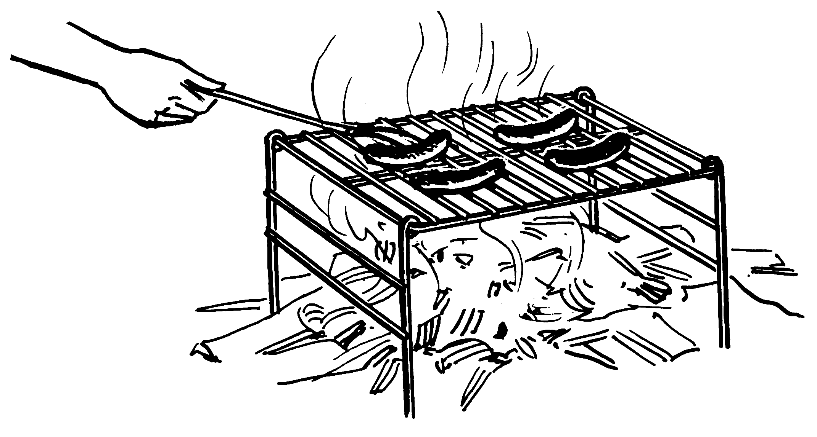
A CHARCOAL GRILL FOR COOKING WILL BE PROVIDED
Questions? Contact Bob R: 814-470-2210

Please note: There is NO cell-phone or GPS reception at Poe Valley State Park! This is a primitive back-woods recreation area, with no lifeguards, and very rustic accommodations. Keep your eyes open, your expectations realistic, and be aware that Mother Nature in all Her Glory and Power lives here.

(see directions other side)
TO POE VALLEY STATE PARK:
From north and west –
travel east on Rte 45 (Earlystown Rd, becomes Penns Valley Rd after Old Fort) from State College/Boalsburg area, approximately 25 miles, almost to Millheim – turn right on Paradise road at the sign for Poe Valley State Park - continue to the end of Paradise Road, and despite the sign, go straight across the bridge and up the mountain – the road becomes Green Briar Gap Road, and then joins with the Siglerville-Millheim Pike – follow that road up the mountain, around the bends, and then down, approximately 6 miles – at the deadend turn sharp left and continue to Poe Valley State Park on the right, approximately 3 miles – follow the road around and down to the lower level by the lake and park where you can –– look for an AA sign
From south –
travel west on Rte 322 up through Seven Mountains – after the top, watch for a sign to Poe Valley State Park on the right – turn right and drive past Seven Mountains Boy Scout Camp & continue winding along Sand Mountain Road – at the dead end, about 6 miles, turn left toward Poe Valley State Park – follow the road another 5-6 zig-zag miles to the entrance to the Park on the right - follow the road around and down to the lower level by the lake and park where you can –look for an AA sign
From the east –
travel west on Rte 45 from Mifflinburg approximately 15 miles through Millheim to Paradise Road on the left – you will see a sign for Poe Valley State Park – turn left onto Paradise Road - continue to the end of Paradise Road, and despite the sign, go straight across the bridge and up the mountain – the road becomes Green Briar Gap Road, and then joins with the Siglerville-Millheim Pike – follow that road up the mountain, around the bends, and then down, approximately 6 miles – at the deadend turn sharp left and continue to Poe Valley State Park on the right, approximately 3 miles – follow the road around and down to the lower level by the lake and park where you can –look for an AA sign

REMEMBER –
THERE IS NO CELL PHONE RECEPTION ONCE YOU GET TO THE TOP OF THE FIRST MOUNTAIN

PLEASE TRAVEL WITH CARE – AMISH BUGGIES, BICYCLISTS & CRITTERS SHARE THE BACKWOODS DIRT ROADS

