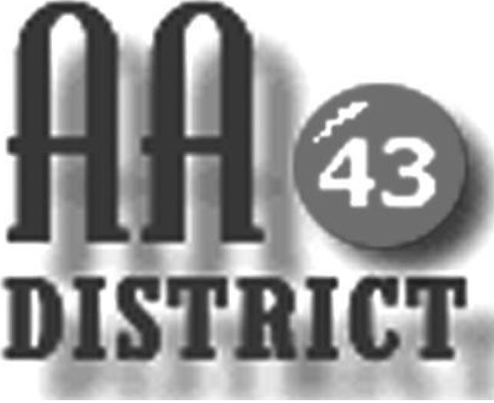

Meeting Minutes
April 11, 2017

Groups Represented:

Came to Believe
Keep it Simple Sunday
Centre Hall - Millheim Group
Monday 5:30 Happy Hour Promises
Primary Purpose – Howard Monday Night
Saturday Morning Gratitude
Sunday Night Healing Group
Thursday Sober Sisters
Tuesday Twelve Step
Wednesday Night Living in the Solution

Because the church key was not available the meeting was held at the pick-nick pavilion behind the church. The meeting called to order at 7:15 pm with the Serenity Prayer.

Officer Reports:

Officer-at-Large (Jen): No major issues were reported.

Secretary (Paul H.): Shannon noted that the minutes from the March 21 meeting indicate February 28 as the date of the financial report and that this should be January 31. With this correction, the minutes of the March 21 meeting were approved. Paul distributed a newly updated 2017 panel roster listing each panel member by first name with e-mail and phone numbers for corrections and additions.

Treasurer (Shannon): The District financial report for March 2017 is attached. Shannon reported that as of February 28 the District fund balance is $992 above the prudent reserve of $1,200. Of this total, $142.00 are designated “pink can” funds and 850 is available for other district business.

Shannon then raised a question about bills she is receiving for periodic payment by District for advertisement of the AA hotline in the telephone book yellow pages. There was some discussion about whether advertising in the yellow pages is an effective way of spreading the AA message, and on the more basic question of whether this may constitute promotion rather than attraction. It was agreed that GSRs would discuss these questions with their home groups and that this would be discussed at the next District meeting.

Web Servant (John): John reported that information about Cook Forest is needed for the website. Carrie said that she would help John with this.

ADCM (Bob): Bob reported that people are having trouble locating the room for the meeting at the hospital, which is Conference Room 1. He suggested that clearer directions to the location could be made available both at the hospital information desk and on the website and meeting list. It was agreed that Carrie, Bob, and John would look into this.

DCM (Carrie): Carrie reported on Area 59 events including the April 2 Pre-Conference Sharing Day which she attended, and the upcoming June 10 Mini Assembly. She explained that these events are designed to engage districts and groups in planning for the fall EPGSA Conference. Carrie also reported that she had “manned” an AA table at an event providing information about AA. She also circulated a printed transcript of telephone calls to AA for a three-month period.

Summaries and Actions

It was reported that residents at the Meadows may be missing meetings because they are having difficulty moving from their location to the location of the meeting at the Meadows due to staffing and logistics issues. It was determined that this would require some direct discussion with the Meadows administration, and DT volunteered to do that and he will report back.

Committee Reports

Archives: No major issues were reported.

Corrections & Institutions (C&I): Bill has stepped down as chair of this committee. Megan volunteered to serve as chair.

Cooperation with the Professional Community (CPC): No major issues were reported.

Public Information (PI): No major issues were reported.

Structure: No major issues were reported.

Visitation: No major issues were reported.

Old Business: No old business was discussed.

New Business: No new business was discussed.

The meeting adjourned at 8:10 p.m.

