

**BIG BOOK SEMINAR**

**BETHANY RETREAT CENTER**

**1031 GERMANIA ROAD**

**FRENCHVILLE, PA. 16836**

**OCTOBER 19TH AND 20TH, 2018**

FRIDAY REGISTRATION 4PM-7PM

DINNER 6PM

FRIDAY PROGRAM 7 PM – 9:30 PM

SATURDAY BREAKFAST 8 AM

SATURDAY PROGRAM 9 AM – 5 PM

**A BIG BOOK SEMINAR PATTERNED AFTER THE ”JOE AND CHARLIE” PROGRAM**

“***Having had a spiritual awakening as a result of these steps, we tried to carry this message to alcoholics, and to practice these principles in all our affairs.”***

**Seminar Registration form:** *please indicate your registration choice below by checking the appropriate box.*

**□** Registration only $30. □ Registration and Meals $60.

□ Registration, Lodging & meals $155.

Name:___________________________________

Address___________________________________

Phone:____________________________________

Email:_____________________________________

REGISTER BY CLIPPING AND MAILING THIS FORM ALONG WITH YOUR CHECK OR PAYMENT TO:

**BIG BOOK SEMINAR**

**BETHANY RETREAT CENTER**

**1031 GERMANIA ROAD**

**FRENCHVILLE, PA. 16836**

***QUESTIONS? Joe W. Home (814) 938-5875 Cell (814) 590-4445***

***Sam D. Email: Samueldavis_4459@msn.com***

SPEAKERS: *BRIAN H. and PAT R. from Ft. Lauderdale, Florida*

***SPACE IS LIMITED!!!! REGISTER ASAP TO INSURE A PLACE!!!***

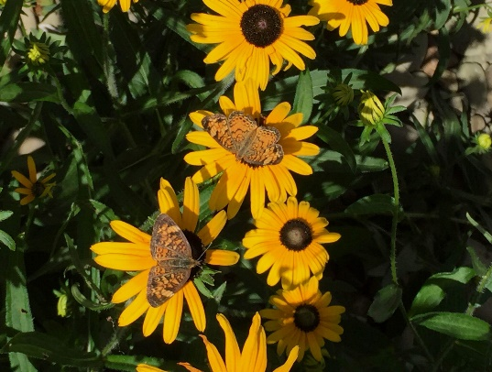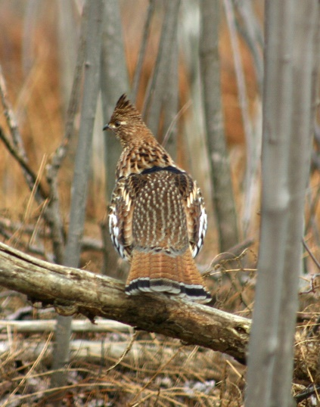

**BIG BOOK SEMINAR**