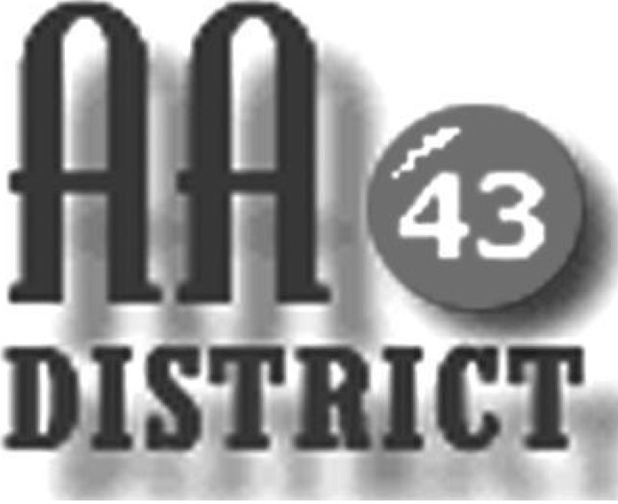

Meeting Minutes

October 9, 2018

Groups Represented

Monday 5:30 Happy Hour Promises
Friday Night Spiritual Side
Tues/Thurs Primary Purpose
Tuesday Night Step Meeting Bellefonte
Centre Hall Saturday Night Discussion
Sunday Came to Believe
Boalsburg Monday As Bill Sees It
Friday Teachables
Friday Night Milesburg Meeting
Tuesday Night Young Hope
Tuesday Night Twelve Step
Sunday Came to Believe
Saturday Night Living Sober
Sunday Eleventh Step Healing Group
Wednesday Living in the Solution
Wednesday Night Recovery

The meeting was held at St. Luke’s Lutheran Church in Centre Hall and was called to order at 7:15 p.m. with the Serenity Prayer.

Officer Reports:

Officer-at-Large (Jen): The next District meeting will be held on November 13 at St. Andrew’s Church in State College.

Secretary (Paul H.): The minutes of the September 11 meeting were approved.

Treasurer (Shannon): Shannon reported that as of September 30 the total available funds are $1,586.68 above the prudent reserve of $1,200.

Web Servant (Tad): Tad asked GSRs to e-mail to him any announcements of any AA business including new meetings that they wish to have posted on the website. He says that he prefers to received announcements in PDF format.

ADCM (Bob): No report.

DCM (Carrie): Carrie thanked Bob for serving as Acting DCM during her two-month absence. She also encouraged GSRs to attend Area Day on October 14 and said that anyone wishing to attend could ride with she and Bob.

Summaries and Actions

Bob reported that Medallion Night will be held on October 12. He also reminded GSRs that a Corrections Workshop will be held on October 27 in Danville. Bob indicated that he plans to attend the Corrections Workshop.

Committee Reports

Archives: No report.

C&I (Corrections & Institutions): It was reported that twelve AAs from District 43 attended the PREA training on September 18. PREA training is required in order to enter a prison. Carrie asked the C&I committee to develop a recommendation to District for the purchase of literature for use in corrections facilities as one way to make good use of our current budget surplus.

CPC (Cooperation with the Professional Community): No report.

PI (Public Information): Carrie said that she would like to produce copies of meeting lists, pamphlets, and other materials for the incoming panel. A motion was approved authorizing Carrie to spend up to $100 for this purpose.

Structure: No report.

Visitation: Jamie reported that he is now mailing a form to all of the groups that he is aware of that are not represented at District to collect information about those groups for the next panel.

Old Business

Lisa distributed a very nice AA social events flier from District 46 in Wellsboro and asked whether our District would want to undertake an AA social events coordination role similar to what District 46 is doing. Carrie asked GSRs to obtain input from their groups on this idea and also said that if there is interest, a good next step would be to get input from Area. Bob further suggested that the Structure committee could examine this and if there is agreement, a recommendation could be developed and offered to the next panel.

There was also discuss of the current budget surplus. It was reported that a new meeting in our District, the Wednesday Living Sober meeting, is requesting help from District to purchase Living Sober books for use at their meeting. It was agreed that GSRs should take this back to the groups for discussion, noting that District has never purchased literature or provided any other financial assistance for a single group. There was agreement that purchase of copies of Grapevine for use in corrections facilities would be one good use of the funds. A motion was approved authorizing up to $200 to be spent on purchase of Grapevines for use in corrections facilities. It was also agreed that District funds could be used to assist AAs attend the EPGSA conference if anyone needs such help, and GSRs were asked to take this to their groups.

New Business:

It was noted that officer elections will be held at next month’s meeting. Carrie explained the election procedures, which is that for each office, all panel members will be asked individually if they wish to decline or stand for election to the office.

The meeting adjourned at 8:50 p.m.

