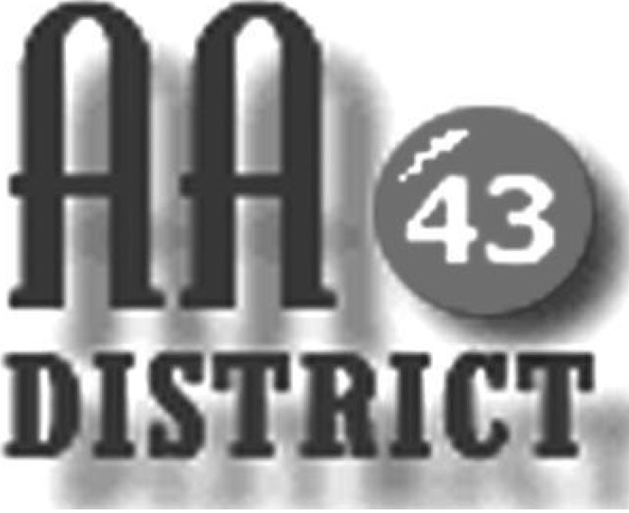

Meeting Minutes

November 13, 2018

Groups Represented

Monday 5:30 Happy Hour Promises
Monday Night Winners
Monday Night As Bill Sees It Boalsburg
Tuesday Night Step Meeting Bellefonte
Tuesday Night Young Hope
Tuesday Night Twelve Step
Tues/Thurs Primary Purpose
Wednesday Living in the Solution
Wednesday Night Recovery
Wednesday Twelve Step Meeting
Thursday Night Sober Sisters
Friday Teachables
Friday Night Spiritual Side Milesburg Meeting
Saturday Morning Gratitude
Saturday Night Living Sober
Saturday Night Discussion Centre Hall
Saturday Millheim Group Centre Hall
Sunday Came to Believe
Sunday Eleventh Step Healing Group
Sunday Keep It Simple Sundays
Sunday Sober Sundays
Attitude adjustment (Monday-Friday, Saturday)

The meeting was held at St. Andrews Episcopal Church, State College PA and was called to order at 7:15 p.m. with the Serenity Prayer.

Officer Reports:

Officer-at-Large (Jen): The next District meeting will be held on December 11 at South Hills Business School in room 25.

Secretary (Paul H.): The minutes were approved with one revision.

Treasurer (Shannon): Shannon has purchased 3 boxes of older issues of Grapevine magazines. These need a home! In October, we had $246.00 incoming contributions and $718.00 total expenses. As of October 31, we had $1,114 available. Carrie still needs to be reimbursed for EPGSA ($338.05). The finances were approved.

Web Servant (Tad): Tad reported that an AA member with cerebral palsy at Whispering Pines reached out for help (e.g., for a ride to meetings). If anyone is available to help, please contact Tad for more information. Tad also reported that he updated the meeting list link on the website.

ADCM (Bob): Bob thanked Carrie for her service and is looking forward to serving as the new DCM.

DCM (Carrie):
- We had 12 voting members plus bob fulfilling ADCM duties as an usher at EPGSA. New area officers: Ken D = Delegate (past Alternate Delegate and Chairperson), Caroline N = Alternate Delegate (past Officer-at-Large), Chairperson = Steve S (past Secretary), Secretary = Curt C (past Treasurer), Treasurer Sue M (past DCM D48 and Finance Subcommittee Chair), Officer at large = Pete B (Past DCM D44 and Tech Servant). My expenses are $338.05: mileage (274 Miles) $137.00, registration /meals $85.00, hotel $116.05.
- At the Area service level as Structure Subcommittee Chair, I spent considerable time updating and producing the 2019-2020 English and Spanish Area Structure Manuals and Area Maps. Also at EPGSA, the Structure Subcommittee presented a workshop. Finally, we are preparing our recommendations for the next subcommittees and Delegate.
- It has been an honor to serve as our D43 DCM. May the next servants have the same experience. With gratitude!

Summaries and Actions

- NERAASA Baltimore February 22-24
- Jamie needs a home group to host medallion night in January.
- Monday Night Winner Meeting is hosting their 70th anniversary celebration sometime in December.

Committee Reports

Archives: No report.

C&I (Corrections & Institutions):
- Volunteers are needed for the Youth Detention Center meeting held on Monday nights at 6 pm. The only requirements are three months sobriety plus a photo ID.
- The committee requested that we order more Big Books and 12 & 12’s. Eric suggested purchasing the little Big Books to save money. We will decide on books to order at our December meeting.

CPC (Cooperation with the Professional Community):
- Roger met with incoming hotline volunteers for Q and A. He reported that not all volunteers had attended an AA meeting yet. He also voiced his concern about the preparedness of the volunteers for answering the phones. Roger will bring the new hotline sign-up sheets next month for everyone to taker back to their home groups.

PI (Public Information):
- 850 pamphlets ($67.00); meeting lists needs to be updated before we print, and total will be $108.00+tax.
- Check the District website to make sure that your groups’ information is correct and if not, please email Tad with the updated information.

Structure: No report.

Visitation: Jamie reported that he sent updated GSR forms to Area.

Old Business
- Group feedback regarding fellowship committee. Forward this idea to next panel and discuss with your home groups.
- Group feedback regarding District purchase of “Living Sober” books for new Wednesday noon Bellefonte meeting.
New Business:
- DT made everyone aware of the new pamphlets available at aaws.org: “The God word – Agnostic and Atheist members in AA” and “AA for Alcoholics with Mental Health Issues – and their sponsors”.

Officer elections:
24 total voting members (substantial unanimity needed to elect is 2/3 or16 votes).

POSITION FINAL
DSM Bob
ADCM OPEN
SECRETARY Jen
TREASURER Lisa
OAL Jamie
WEB SERVANT Tad

The meeting adjourned at 8:50 p.m.

